**PSY 653 Module 3: Nested and Incomplete Designs**

**Feb 12, 2020**

*Part 1: In-Class Demo*

Follow along as we talk through the steps of conducting a nested ANOVA. We will use the datafile “Nested_demo.csv” for this exercise, which includes simulated data.

1. This datafile includes data from 114 patients who participated in study to evaluate the effects of different drugs and treatment conditions on their health. This demo dataset has four variables: Y = the outcome variable for health, H = Hospital (i.e., there were two hospitals), D = Drug (i.e., four different drugs were tested), C = Condition (i.e., six different treatment conditions were tested). This is the underlying structure of the data:

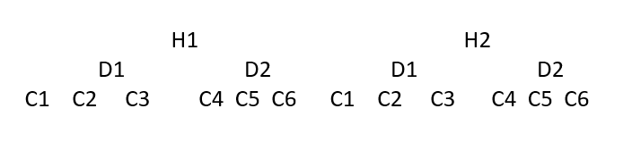

1. How are the variables nested? How does this nesting impact your analysis plan?
2. Create a new R notebook
3. Read in the datafile “Nested_demo.csv”, check how the variables are read, and get variable descriptives
4. Use the aggregate function to calculate the mean values of Y by Hospital, Drug, and Condition.
   1. How much do the means of Y vary across the levels of each predictor?

5) Use the following methods to analyze the effects of Hospital, Drug, and Condition on Y:

1. Create an ANOVA Table listing the factors included in the design and the df for each
2. Conduct a Hospital x Drug ANOVA (ignoring Condition), and plug key results from this analysis into the ANOVA table
3. Conduct a separate ANOVA for the effect of Condition under each possible combination of Hospital and Drug, and plug results from this into the ANOVA Table
4. Conduct an ANOVA that evaluates the full nested model for the effect of hospital, drug, and condition on Y. Compare these results to the ANOVA table you filled in from parts 5b-c.
5. Interpret the overall ANOVA table

*Part 2: Try It Yourself*

Use the “Nested_practice.csv” datafile to practice conducting a nested ANOVA on your own.

1. This datafile includes data from 114 patients who participated in study to evaluate the effects of different drugs and treatment conditions on their health. This demo dataset has four variables: Y = the outcome variable for health, H = Hospital (i.e., there were two hospitals), D = Drug (i.e., four different drugs were tested), C = Condition (i.e., six different treatment conditions were tested). This is the underlying structure of the data:

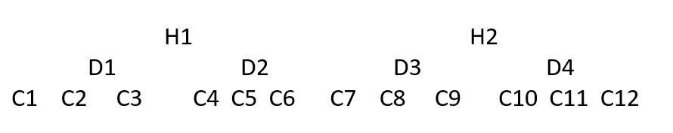

* 1. How are the variables nested? How does this nesting impact your analysis plan?

1. Read in the datafile “Nested_practice.csv”, check how the variables are read, and get variable descriptives
2. Use the aggregate function to calculate the mean values of Y by Hospital, Drug, and Condition.
   1. How much do the means of Y vary across the levels of each predictor?
3. Use the following methods to analyze the effects of Hospital, Drug, and Condition on Y:
   1. Create an ANOVA Table listing the factors included in the design and the df for each
   2. Conduct a one-way ANOVA for Hospital (ignoring Condition and Drug), and plug the relevant results into the table
   3. Conduct a one-way ANOVA for Drug (ignoring Condition), and plug relevant results into the ANOVA table
   4. Conduct a one-way ANOVA for Condition, and plug results into the ANOVA table
   5. Conduct an ANOVA that evaluates the full nested model for the effect of hospital, drug, and condition on Y. Compare these results to the ANOVA table you filled in in parts 4b-d.
   6. Interpret the overall ANOVA table